DEPARTMENT OF RELIGION

HEAD OF DEPARTMENT

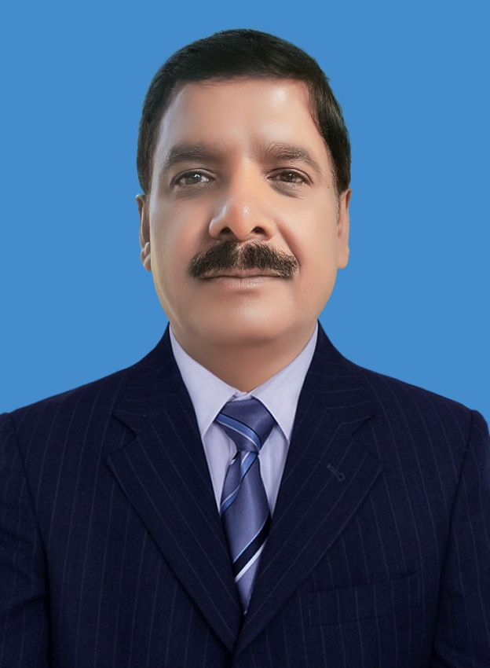

Ashraf Yaqub, M. Div.

“The knowledge of the holy is understanding; “Acquaint now thyself with Him.”
“Our ideas of education take too narrow and too low a range. There is need of a broader scope, a higher aim. True education means more than the pursue of a certain course of study. It means more than a preparation for the life that now is. It has to do with the whole being and with the whole period of existence possible to man. It is the harmonious development of the physical, the mental, and the spiritual powers. It prepares the student for the joy of service in this world and for the higher joy of wider service in the world to come.” E G White, Education, pp. 13.

Faculty Members:

Full Time Lecturers:

Ashraf Yaqub, MA in Divinity, ZBS Rawalpindi

Shakeel Javaid
B.TH., Pakistan Adventist Seminary & College

Akif Javaid
M. Div., AIIAS, Philippines

Part Time Lecturers:

Zubaid R Khan
M.A. Education, Al-Khair University SKP; PhD, Curriculum and Instructions, AIIAS, Philippines

Amdad Jalal
B.A., M.A. Political Science, University of Punjab; M.B.A. Preston, Lahore

Uzma Sohail
MA, Education, University of Punjab, Pakistan
PROGRAMS AND COURSES

BACHELOR OF ARTS IN MINISTRY

The main aim of the Bachelor of Arts in Ministry degree program is that through a focus on biblical, historical, theological, and practical studies, the program equip the student with the knowledge, skills and character needed for effective Seventh Day Adventist service in local churches and other ministries. Graduates find employment in the Pakistan Seventh Day Church as well as abroad. The program is mainly taught in English.

DEGREE STRUCTURE AND REQUIREMENTS FOR GRADUATION

For the Bachelor of Arts in Ministry degree, 130 credit hours are required for graduation. General education courses comprise 18 credit hours, foundation courses comprise 16 credit hours, cognate courses comprise 5 credit hours, and core professional courses comprise 91 credit hours.

Further details are outlined below:

Courses | Credit hours
Foundation | 20
General | 16
Cognates | 5
Core professional | 90
Total | 131

SPECIFIC COURSE REQUIREMENTS

Foundation Courses
(20 Credit Hours)

Code | Course | Cr.
GCS196 | Word Processing | 2
GGS111 | Introduction to Research Techniques | 2
GPE11 | Physical Education I | 1
GPE12 | Physical Education II | 1
GPE13 | Physical Education III | 1
GPE14 | Physical Education IV | 1
LEN101 | English I | 3
LEN102 | English II | 3
LUR111 | Urdu I | 3
LUR112 | Urdu II | 3

General Courses
(16 Credit Hours)

Code | Course | Cr.
EDU132 | Philosophy of Adventist Education | 2
LEN151 | English III | 3
GHY203 | World History I | 3
GHY204 | World History II | 3
LUR151 | Urdu III | 3
SMA105 | General Mathematics I | 2

Cognate Courses
(5 Credit Hours)

Code | Course | Cr
GPY101 | General Psychology I | 3
LSH153 | Fundamentals of Speech | 2

Core professional Courses
(90 Credit Hours)

Code | Course | Cr
EDM282 | Strategies in Teaching Bible Classes | 2
RBS151 | Life and Teaching of Jesus | 3
RBS152 | Acts and Epistles of Paul | 3
RBS211 | The Prophecies of Daniel | 2
RBS212 | Prophecies of Revelation | 2
RBS232 | Hebrew Prophets | 2
RBS248 | Survey of Old Testament | 3
RBS261 | Archeology and the Bible | 3
RBS275 | New Testament Exegesis | 2
RCH221 | History of Christianity I | 3
RCH222 | History of Christianity II | 3
RCH273 | History of the SDA Church | 2
RCX98 | B. Min Comprehensive Examination | 0
RMN115 | Pastoral Ministry | 2
RMN122 | Seminar in Child Evangelism | 1
RMN164 | Homiletics I | 2
RMN202 | Public Evangelism | 3
RMN217 | Homiletics II | 2
RMN221 | Family Life Seminar | 1
RMN226 | Theology of Health | 2
RMN231 | Literature Evangelism Seminar | 1
RMN236 | Principles of Stewardship | 2
RMN241 | Islamic Society and Culture | 2
RMN244 | Introduction to Islamic Religion | 2
RMN255 | Church Music & Worship | 3
RMN268 | Pastoral Care and Counseling | 2
RMN271 | Asian Christianity | 2
RMN276 | Church Administration | 2
RMP11 | Field Practicum I -Deacon Ministry | 0
RMP12 | Field Practicum II -Youth Ministry | 0
RMP13 | Field Practicum III - Colporteur Ministry | 0
RMP14 | Field Practicum IV - Public Evangelism | 0
RMP281 | Pastoral Internship | 1
RRS11 | Project I, II, III (Pastoral Internship) | 3
RTH101 | Christian Beliefs | 3
RTH102 | SDA Theology | 3
RTH221 | Biblical Teaching of Islam | 2
RTH222 | Contextualized Apologetics | 2
RTH253 | Religion & Science | 3
RTH266 | Gift of Prophecy | 2
RTH272 | Christian Ethics | 2
RYM151 | Youth Ministry | 2
RTH285 | Greek Grammar | 2
RTH286 | Hebrew Grammar | 2
RMN291 | Church Planting & Church Growth | 2
RTH295 | Tent Making Mission | 2

PROJECTED SEQUENCE OF CLASSES
Accounting Emphasis

FIRST YEAR

Autumn Semester
Code | Course | Cr. | Prerequisite
GPY101 | General Psychology I | 3
GGS111 | Intro to Research Techniques | 2
GPE11 | Physical Education I | 1
LEN101 | English I | 3
LUR111 | Urdu I | 3
RTH101 | Christian Beliefs | 3
TOTAL: 15

Spring Semester
Code | Course | Cr. | Prerequisite
GCS169 | Word Processing | 2
GPE12 | Physical Education II | 1
LEN102 | English II | 3 | LEN101
LUR112 | Urdu II | 3 | LUR111
RMN115 | Pastoral Ministry | 2
RMP11 | Field Practicum I -Deacon Ministry | 0
RTH102 | SDA Theology | 3 | RTH101
TOTAL 14

Summer
Code | Course | Cr. | Prerequisite
SMA105 | General Mathematics I | 2
TOTAL 2

SECOND YEAR

Autumn Semester
Code | Course | Cr. | Prerequisite
GHY203 | World History I | 3
GPE13 | Physical Education III | 1
LEN151 | English III | 3 | LEN102
LUR151 | Urdu III | 3 | LUR112
RBS151 | Life and Teaching of Jesus | 3 | RTH101
RCH273 | History of the SDA Church | 2 | RTH101
RMP12 | Field Practicum II -Youth Ministry | 0
TOTAL 15

Spring Semester
Code | Course | Cr. | Prerequisite
GHY204 | World History II | 3 | GHY203
LSH153 | Fundamentals of Speech | 2 | LEN102
RBS152 | Acts and Epistles of Paul | 3 | RTH101
RBS248 | Survey of Old Testament | 3 | RTH102
GPE14 | Physical Education IV | 1 | GHY203
RMN271 | Asian Christianity | 2 | GHY203
RTH221 | Biblical Teaching of Islam | 2 | RTH102
TOTAL 16

Summer
Code | Course | Cr. | Prerequisite
RBS275 | New Testament Exegesis | 2
RMN122 | Seminar in Child Evangelism | 1 | RTH102
TOTAL 3

THIRD YEAR

Autumn Semester
Code | Course | Cr. | Prerequisite
EDU132 | Philosophy of Adventist Education | 2
RBS211 | The Prophecies of Daniel | 2 | RTH102
RMN164 | Homiletics I | 2 | LSH153
RRS11 | Pastoral Internship I | 1
RTH222 | Contextualized Apologetics | 2 | RTH102
RTH266 | Gift of Prophecy | 2 | RTH101
RTH295 | Tent Making Mission | 2
RYM151 | Youth Ministry | 2
TOTAL 15

Spring Semester
Code | Course | Cr. | Prerequisite
EDM282 | Strategies in Teaching Bible Classes | 2 | RTH102
RBS212 | Prophecies of Revelation | 2 | RTH102
RBS232 | Hebrew Prophets | 2 | RBS248
RBS261 | Archeology and the Bible | 3 | RBS248
RCH221 | History of Christianity I | 3 | GHY203
RMN217 | Homiletics II | 2 | LSH153
RMN231 | Literature Evangelism Seminar | 1
RRS12 | Pastoral Internship II | 1
TOTAL 16

Summer
Code | Course | Cr. | Prerequisite
RMP13 | Field Practicum III - Colporteur Ministry | 0
RRS13 | Pastoral Internship III | 1
TOTAL 1

FOURTH YEAR

Autumn Semester
Code | Course | Cr. | Prerequisite
RCH222 | History of Christianity II | 3 | RCH221
RMN202 | Public Evangelism | 3 | RMN164
RMN241 | Islamic Society and Culture | 2 | RCH221
RMN244 | Introduction to Islamic Religion | 2 | RMN271
RMN276 | Church Administration | 2 | RTH222
RMP14 | Field Practicum IV - Public Evangelism | 0
RTH285 | Greek Grammar | 2
RTH272 | Christian Ethics | 2
TOTAL 16
Spring Semester
Code | Course | Cr. | Prerequisite
RCX98 | B. Min Comprehensive Examination | 0 | Senior year
RMN221 | Family Life Seminar | 1
RMN226 | Theology of Health | 2
RMN236 | Principles of Stewardship | 2 | RTH221
RMN255 | Church Music & Worship | 3
RMN268 | Pastoral Care and Counseling | 2 | RTH221
RTH286 | Hebrew Grammar | 2
RMN291 | Church Planting & Church Growth | 2
RTH253 | Religion & Science | 3 | RBS248
TOTAL 17

FIFTH YEAR

Autumn Semester
Code | Course | Cr. | Prerequisite
RMP281 | Pastoral Internship | 1 | RCX98

GRAND TOTAL 131

